**Tutorial for MonkeyRunner and Android GUI Testing**

**1. Download Android Studio**

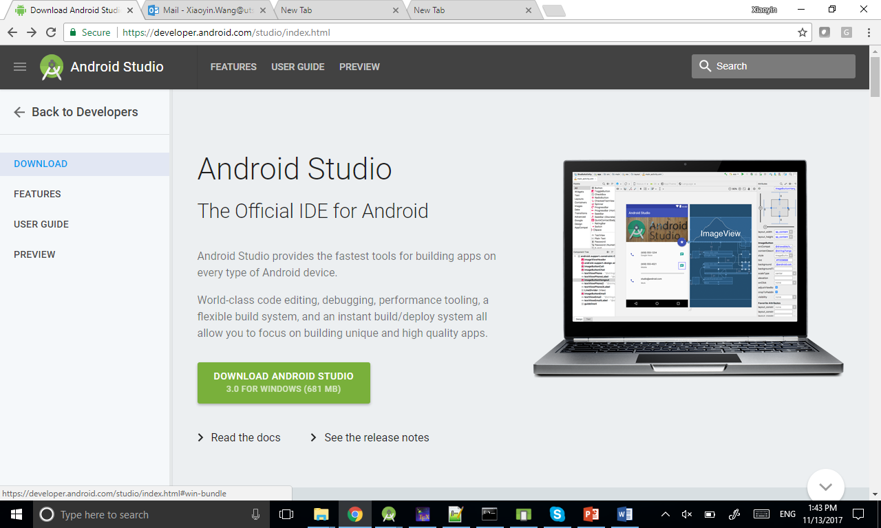

**2. Start Android Studio**

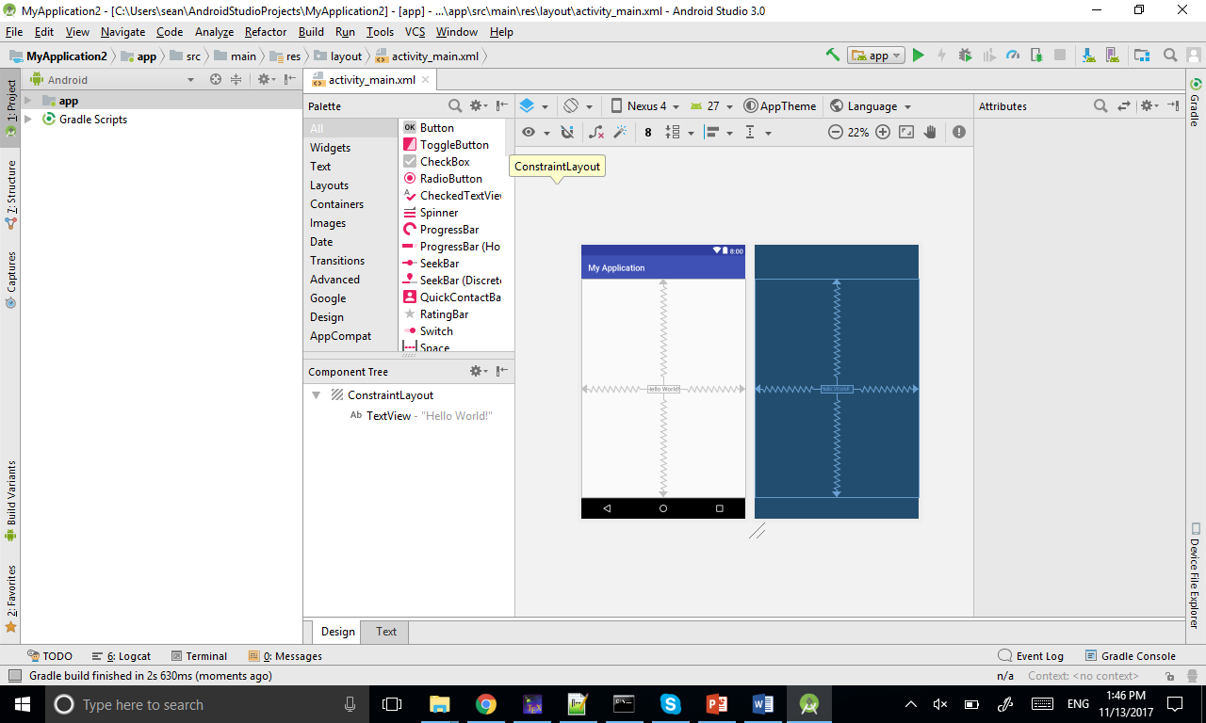

**3. Open AVD Manager**

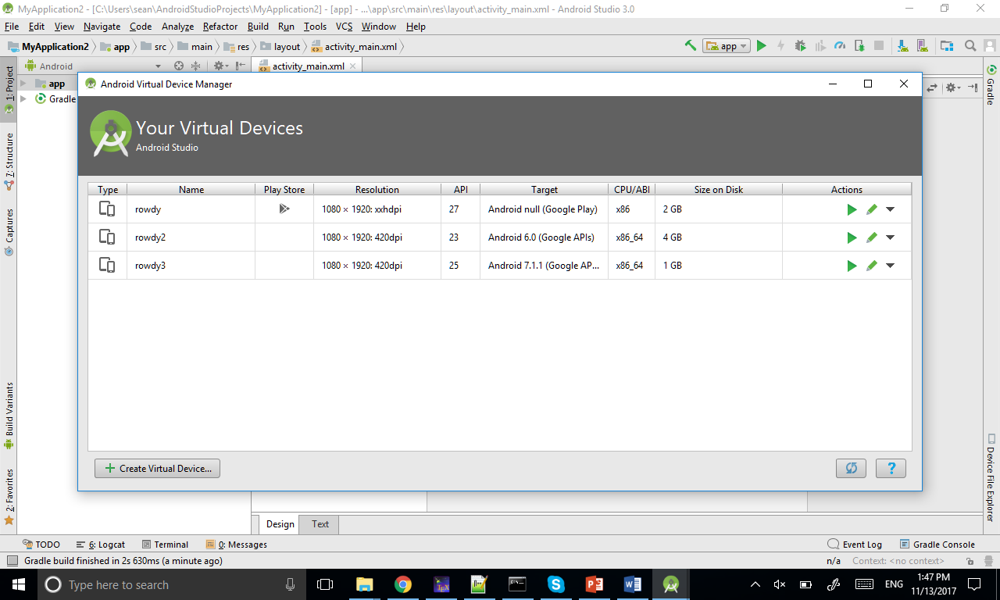

**4. Create Virtual Device and select Pixel 2 1080*1920 (Pixel and Nexus 5 should also work if you do not have Pixel 2 option)**

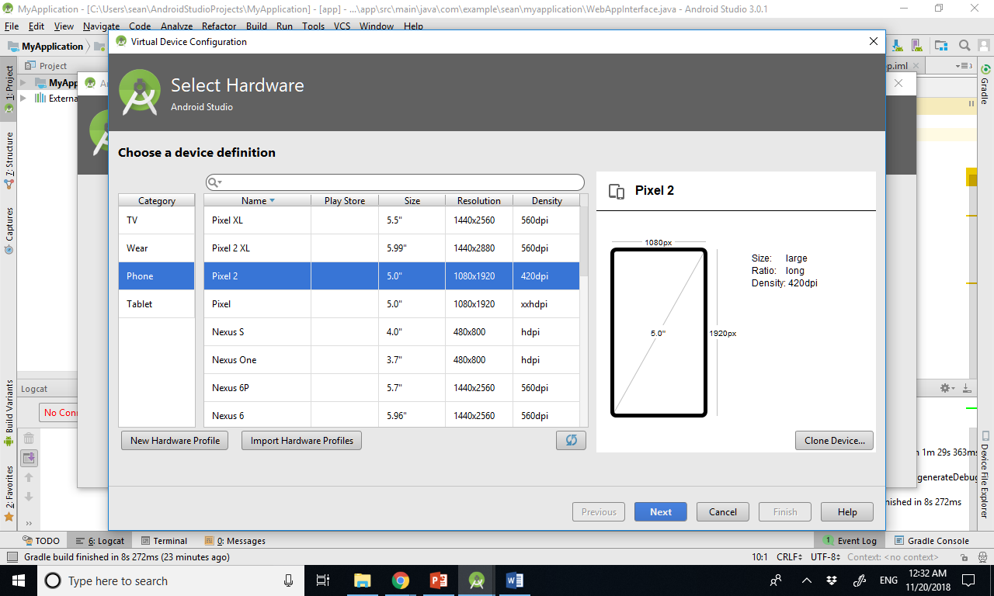

**5. Go to x86 Images and choose Nougat API 25, x86_64, you may need to click on the blue Download if you do not have it. It may take 20 minutes.**

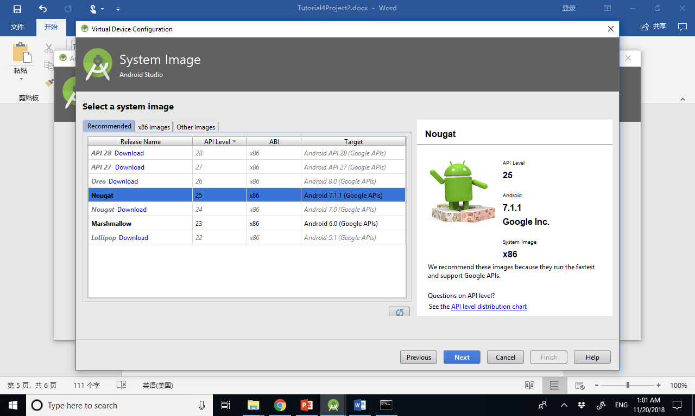

**6. Give a name to the AVD**

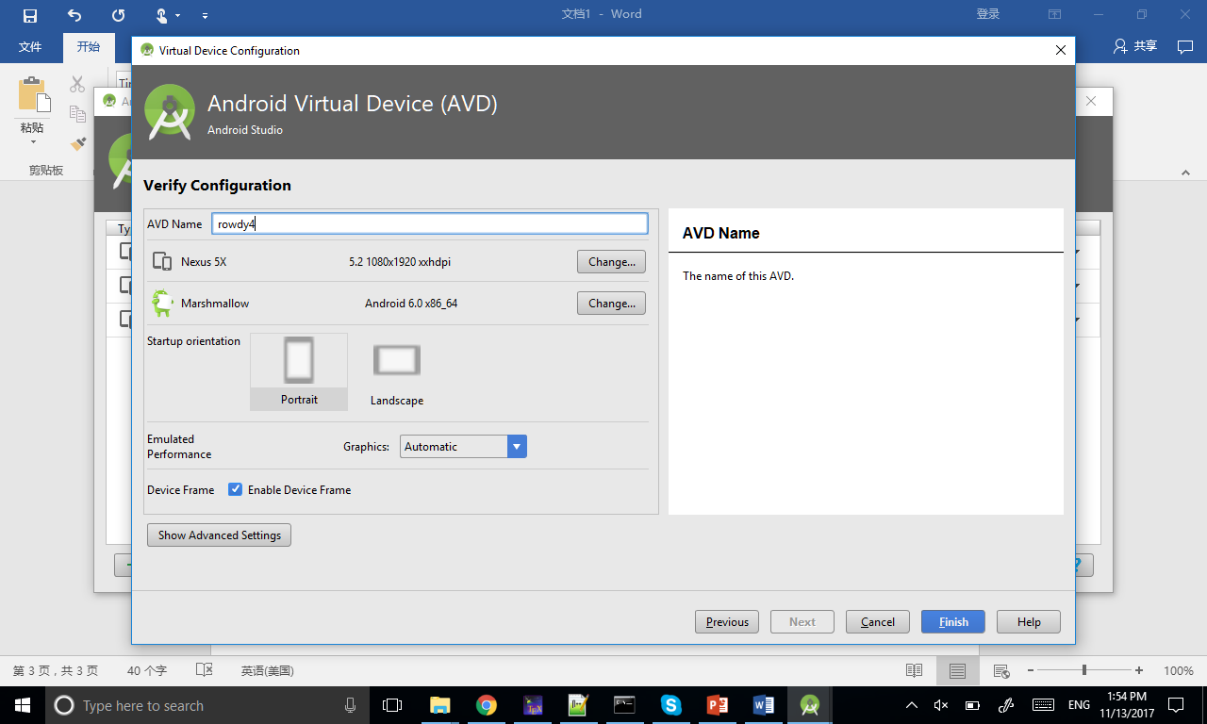

**7. Click on the play button and the emulator should start**



**8. Go to settings, about emulated device, and click on the last item for 7 times, to become a developer**

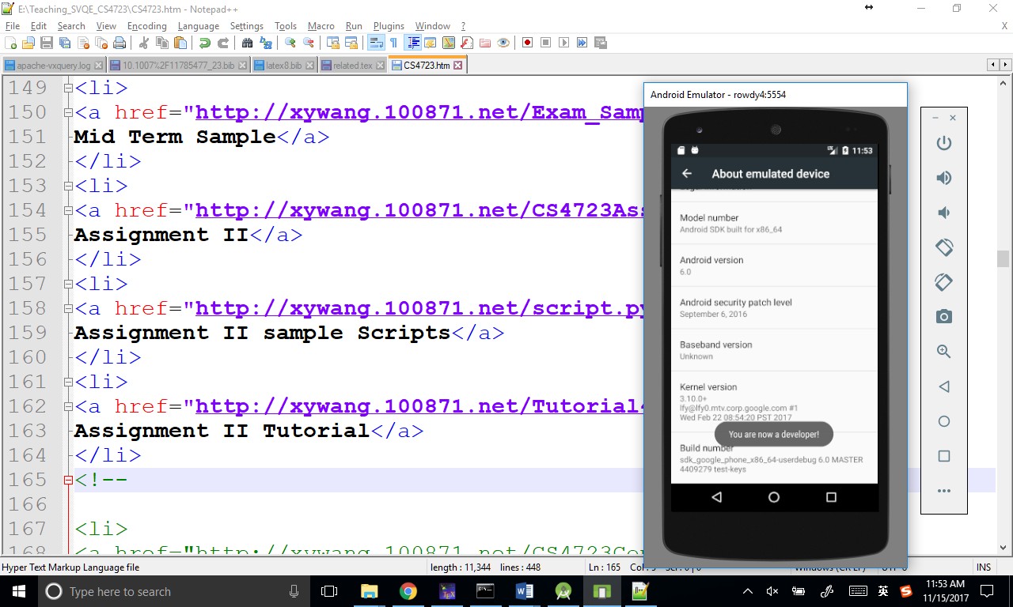

**9. Go back on level, and now you can see a new item called Developer options. Go into it and enable Pointer Location**

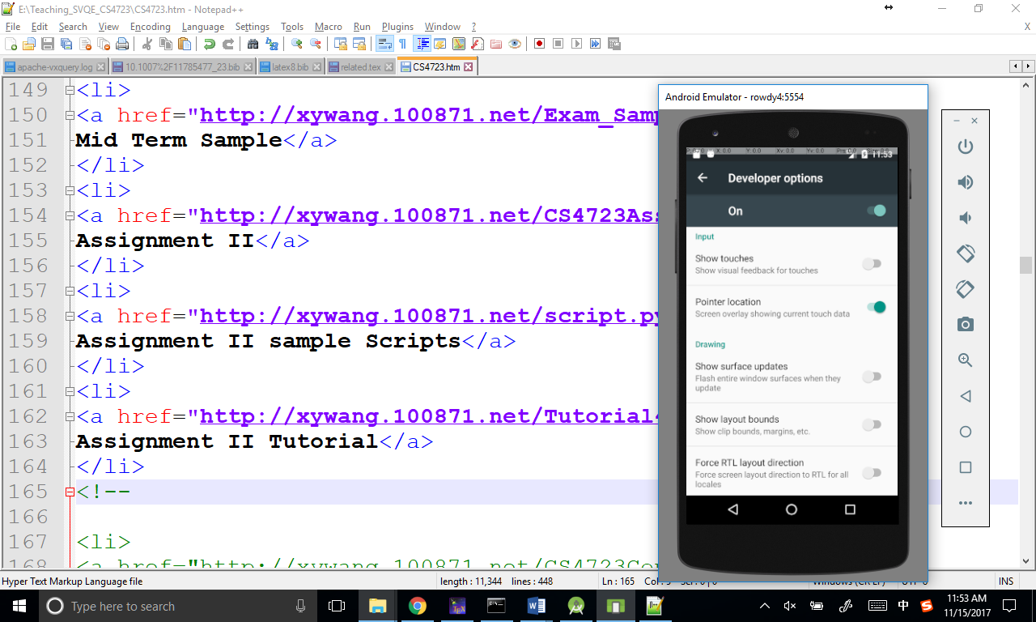

**10. open cmd and go to the folder of Android home, you should find it at File->Project Structure**

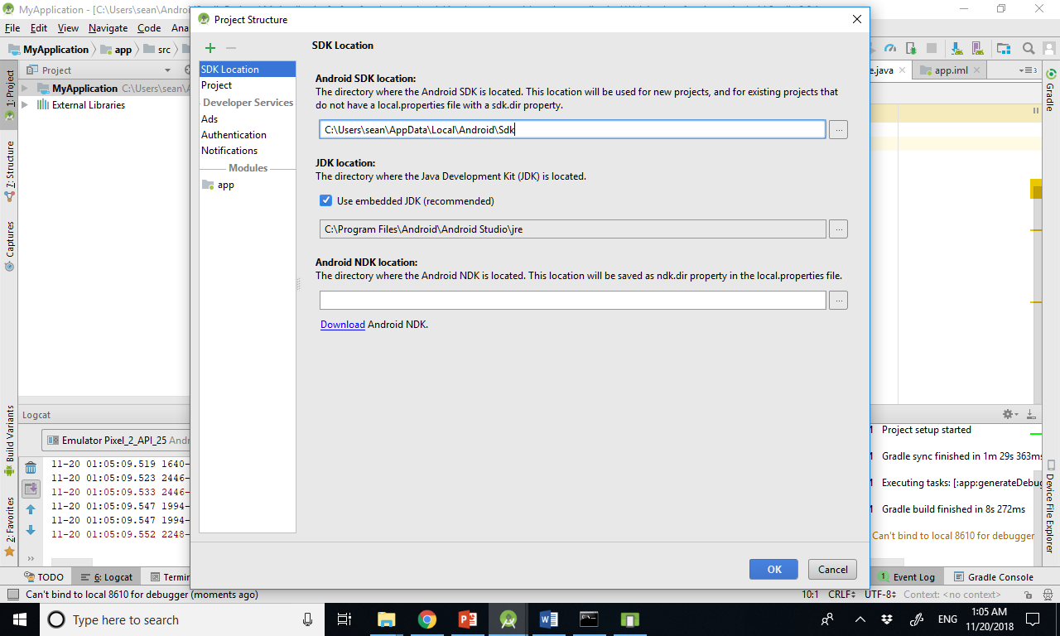

**11. run monkeyrunner script.py, if you are using windows, please download the fixed monkey runner script from the course website.**

